**Course 4 overview**



Hello, and welcome to **The Power of Statistics**, the fourth course in the Google Advanced Data Analytics Certificate. You’re on an exciting journey!

In previous courses, you learned how data professionals contribute to the success of an organization, the basic syntax and functions of the Python programming language, and the main stages of exploratory data analysis (EDA). In this course, you’ll explore how data professionals use statistics to analyze and interpret data to help stakeholders make informed business decisions.

**Course descriptions**

The Google Advanced Data Analytics Certificate has seven courses. **The Power of Statistics** is the fourth course.

1. [**Foundations of Data Science**](https://www.coursera.org/learn/foundations-of-data-science/home/week/1) — Learnhow data professionals operate in the workplace and how different roles in the field of data science contribute to an organization’s vision of the future. Then, explore data science roles, communication skills, and data ethics.
2. [**Get Started with Python**](https://www.coursera.org/learn/get-started-with-python/home/week/1) —Discover how the programming language Python can power your data analysis. Learn core Python concepts, such as data types, functions, conditional statements, loops, and data structures.
3. [**Go Beyond the Numbers: Translate Data into Insights**](https://www.coursera.org/learn/go-beyond-the-numbers-translate-data-into-insight/home/week/1) — Learn the fundamentals of data cleaning and visualizations and how to reveal the important stories that live within data.
4. [**The Power of Statistics**](https://www.coursera.org/learn/the-power-of-statistics/home/week/1) — *(current course)* Explore descriptive and inferential statistics, basic probability and probability distributions, sampling, confidence intervals, and hypothesis testing.
5. [**Regression Analysis: Simplify Complex Data Relationships**](https://www.coursera.org/learn/regression-analysis-simplify-complex-data-relationships/home/week/1) — Learn to model variable relationships, focusing on linear and logistic regression.
6. [**The Nuts and Bolts of Machine Learning**](https://www.coursera.org/learn/the-nuts-and-bolts-of-machine-learning/home/week/1) — Learn unsupervised machine learning techniques and how to apply them to organizational data.
7. [**Google Advanced Data Analytics Capstone**](https://www.coursera.org/learn/google-advanced-data-analytics-capstone/home/week/1) — Complete a hands-on project designed to demonstrate the skills and competencies you acquire in the program.

**Course 4 content**

Each course of this certificate program is broken into modules. You can complete courses at your own pace, but the module breakdowns are designed to help you finish the entire Google Advanced Data Analytics Certificate in about six months.

What’s to come? Here’s a quick overview of the skills you’ll learn in each module of this course.

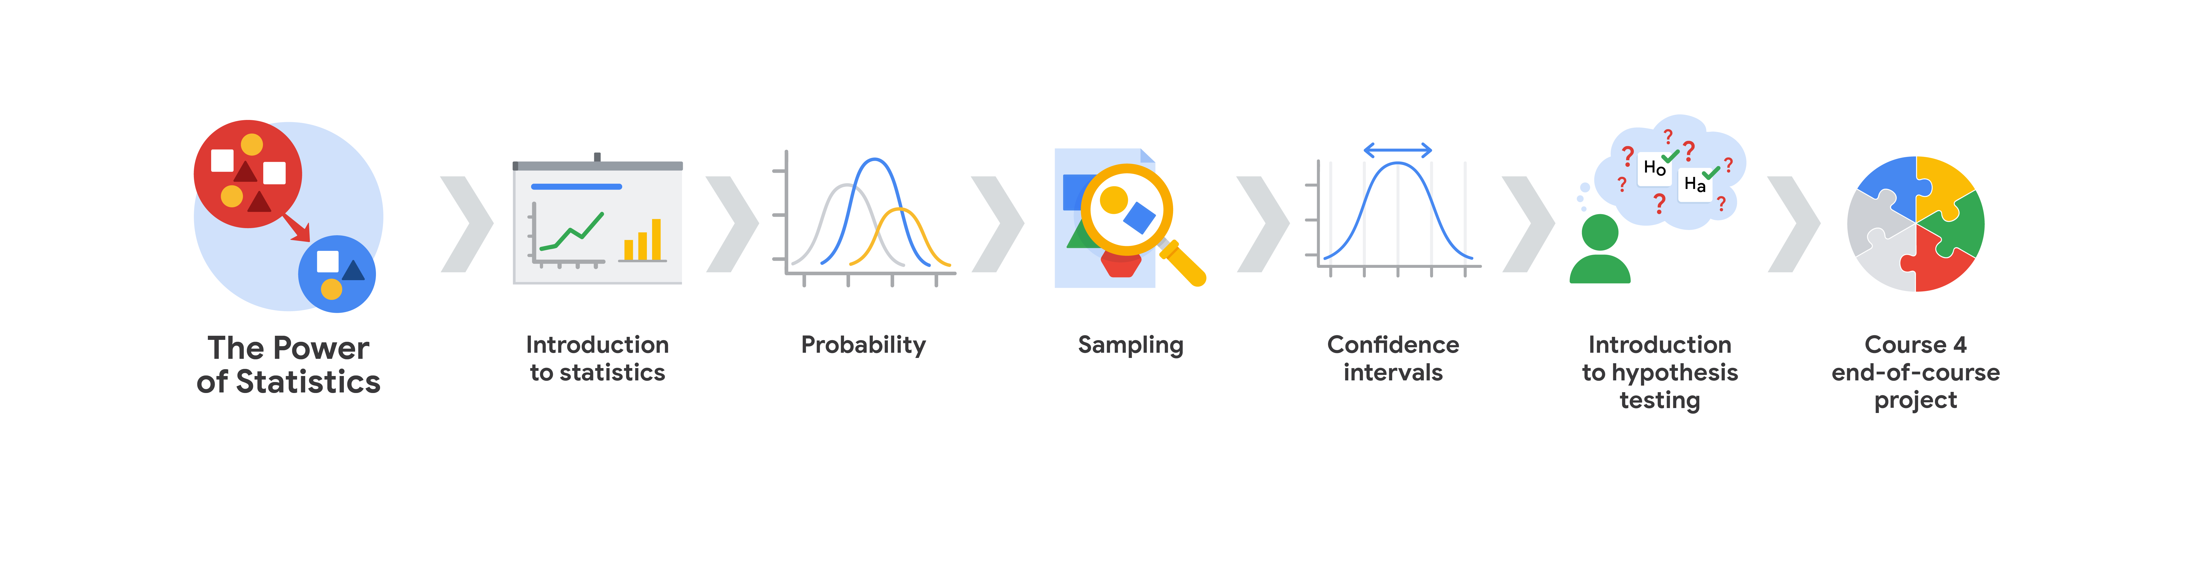

**Module 1: Introduction to statistics**

In this section of the course, you’ll learn about the foundational role of statistics in data science. This section focuses on fundamental concepts of descriptive statistics, such as measures of central tendency, dispersion, and position.

**Module 2: Probability**

You will learn about fundamental concepts in probability. The first half of this section covers basic rules of probability (complement, addition, multiplication), conditional probability, and Bayes's theorem. The second part concentrates on three probability distributions: the binomial, Poisson, and normal distributions.

**Module 3: Sampling**

In this section of the course, you’ll learn about the concept of sampling and its applications in data work. The section begins with an overview of inferential statistics and the relationship between sample and population. This is followed by a summary of the sampling process, and the benefits and drawbacks of specific sampling methods. You’ll also learn about sampling distributions for both means and proportions.

**Module 4: Confidence intervals**

This section explores how data professionals use confidence intervals to describe the uncertainty in their estimates. First, you’ll get an overview of the general procedure for constructing a confidence interval. This is followed by an explanation of how to properly interpret a confidence interval. Finally, you’ll be presented with detailed examples of how to construct a confidence interval for both means and proportions.

**Module 5: Introduction to hypothesis testing**

This section of the course describes how data professionals use hypothesis testing to help determine whether their results are statistically significant. First, you’ll get an overview of the general procedure for conducting a hypothesis test, and guidelines for interpreting the results. Then, you’ll examine detailed examples of how to conduct both one-sample and two-sample tests.

**Module 6: Course 4 end-of-course project**

In this section of the course, you will produce a tangible artifact that you can add to your professional portfolio and present to future employers. For this project, you will use your knowledge of statistics to conduct a statistical test that’s based on a workplace scenario.

**What to expect**

Each course offers many types of learning opportunities:

* **Videos** led by Google instructors teach new concepts, introduce the use of relevant tools, offer career support, and provide inspirational personal stories.
* **Readings** build on the topics discussed in the videos, introduce related concepts, share useful resources, and describe case studies.
* **Discussion prompts** explore course topics for better understanding and allow you to chat and exchange ideas with other learners in the [**discussion forums**](https://www.coursera.org/learn/the-power-of-statistics/discussions).
* **Self-review activities** and **labs** give you hands-on practice in applying the skills you are learning and allow you to assess your own work by comparing it to  a completed example.
* **Interactive plug-ins** encourage you to practice specific tasks and help you integrate knowledge you have gained in the course.
* **In-video quizzes** help you check your comprehension as you progress through each video.
* **Practice quizzes** allow you to check your understanding of key concepts and provide valuable feedback.
* **Graded quizzes** demonstrate your understanding of the main concepts of a course. You must score 80% or higher on each graded quiz to obtain a certificate, and you can take a graded quiz multiple times to achieve a passing score.

**Tips for success**

* It is strongly recommended that you go through the items in each lesson in the order they appear because new information and concepts build on previous knowledge.
* Participate in all learning opportunities to gain as much knowledge and experience as possible.
* If something is confusing, don’t hesitate to replay a video, review a reading, or repeat a self-review activity.
* Use the additional resources that are referenced in this course. They are designed to support your learning. You can find all of these resources in the [**Resources**](https://www.coursera.org/learn/the-power-of-statistics/resources/XBUon) tab.
* When you encounter useful links in this course, bookmark them so you can refer to the information later for study or review.
* Understand and follow the [Coursera Code of Conduct](https://www.coursera.support/s/article/208280036-Coursera-Code-of-Conduct?) to ensure that the learning community remains a welcoming, friendly, and supportive place for all members.